Alexander Varghese, Dominick Arnaldo, Jonathan Bar-Eli, and Sarvesh Soni

Professor Chang

CSAS 4115 BA

13 May 2019

Database Manual

In order to run the website, the user has to first start the website file and database file. To start the database file, he/she must go into the directory the database file is located in and run Windows Powershell within the current directory. Once the user has opened the database file, type “nodemon Database.js” and hit Enter. Provided down below is a screenshot of what should be shown: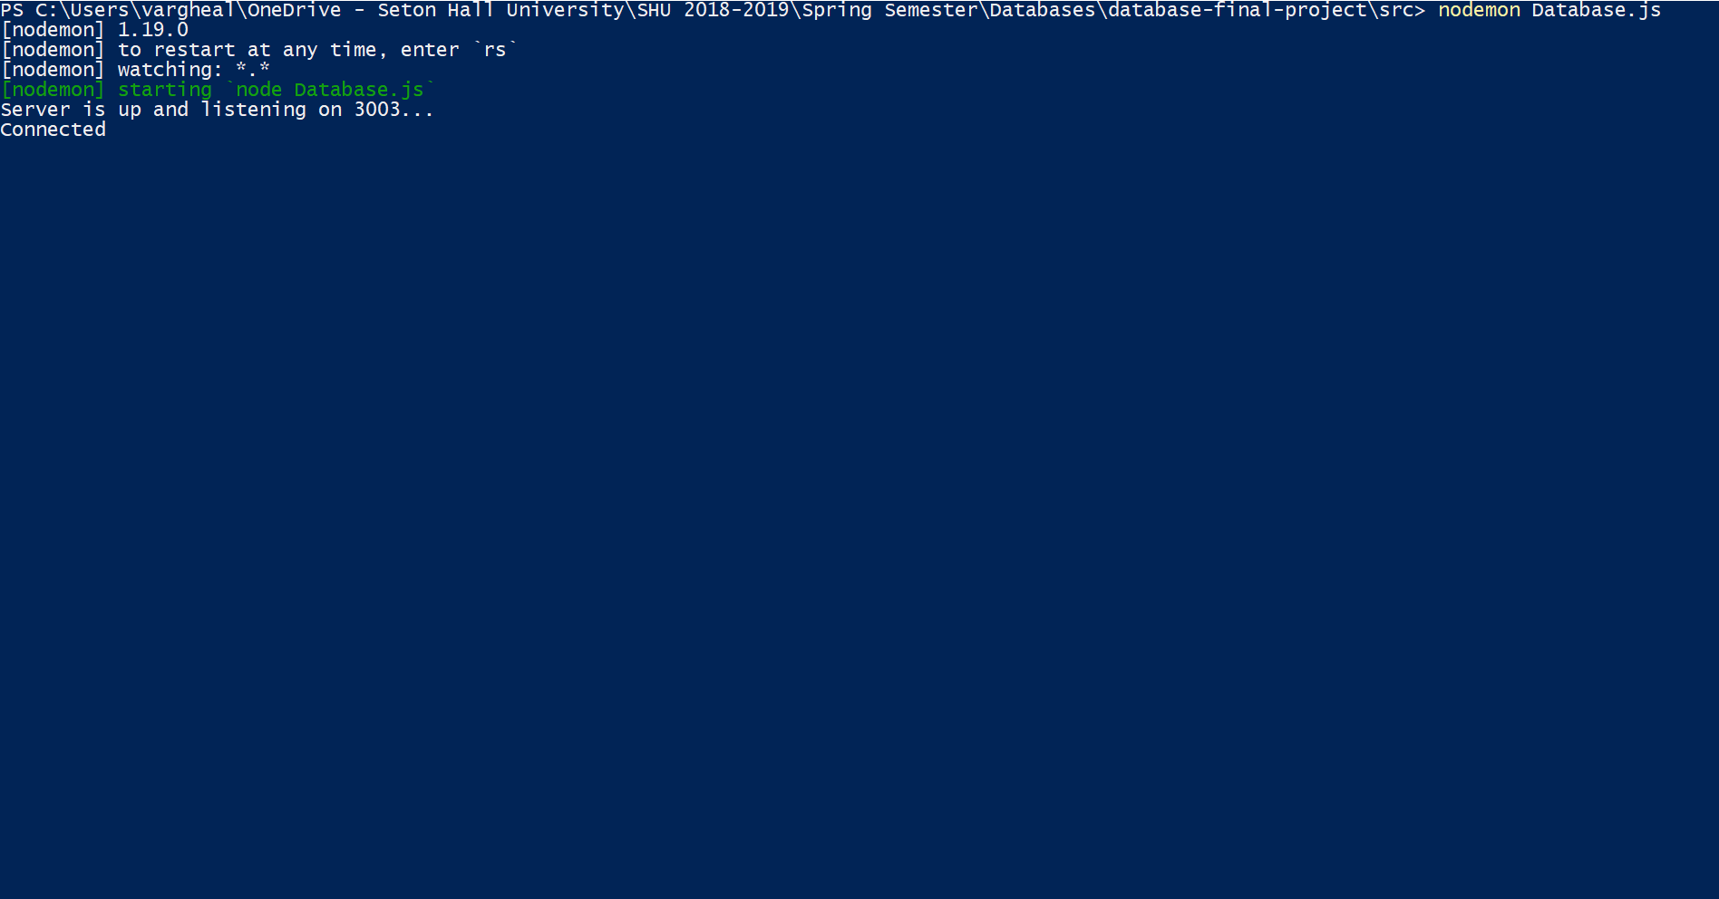

Once the “Database.js” file is running, then run the website by typing into the terminal command in Microsoft Visual Studio code: “npm start” and press Enter. Provided down below I have provided a screenshot to assist the user with starting up the website: 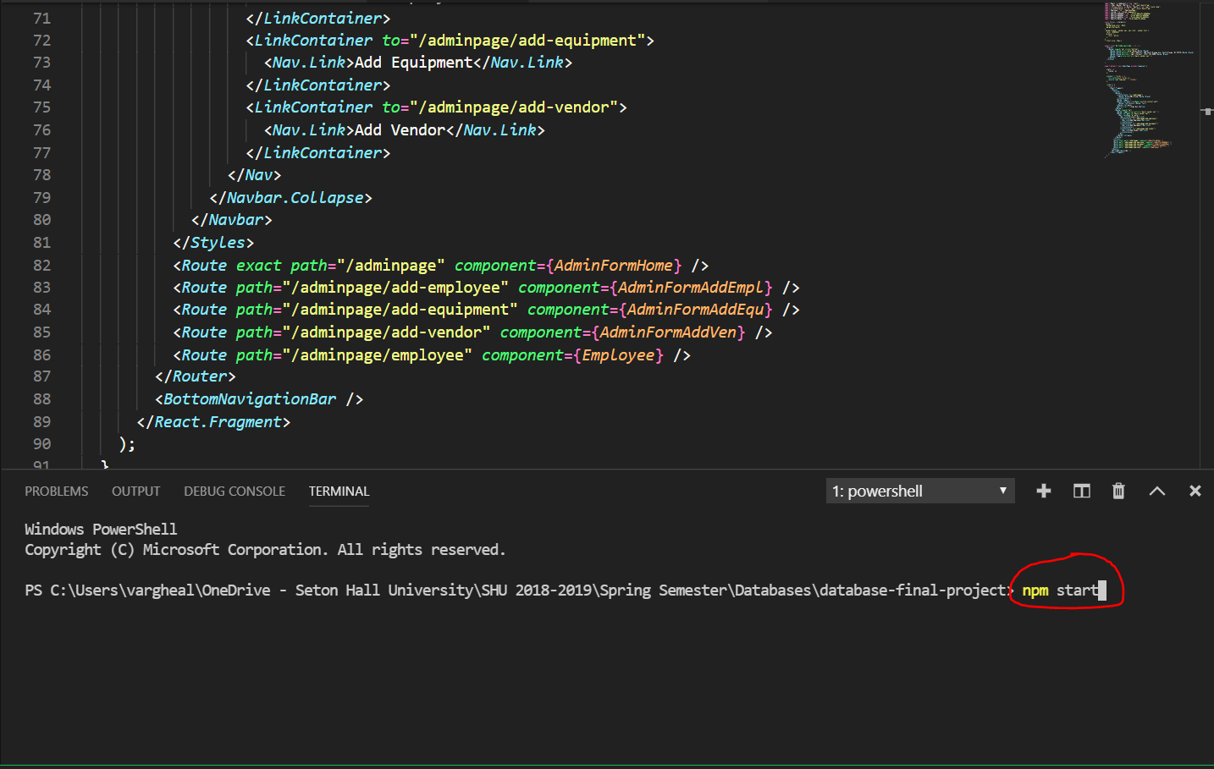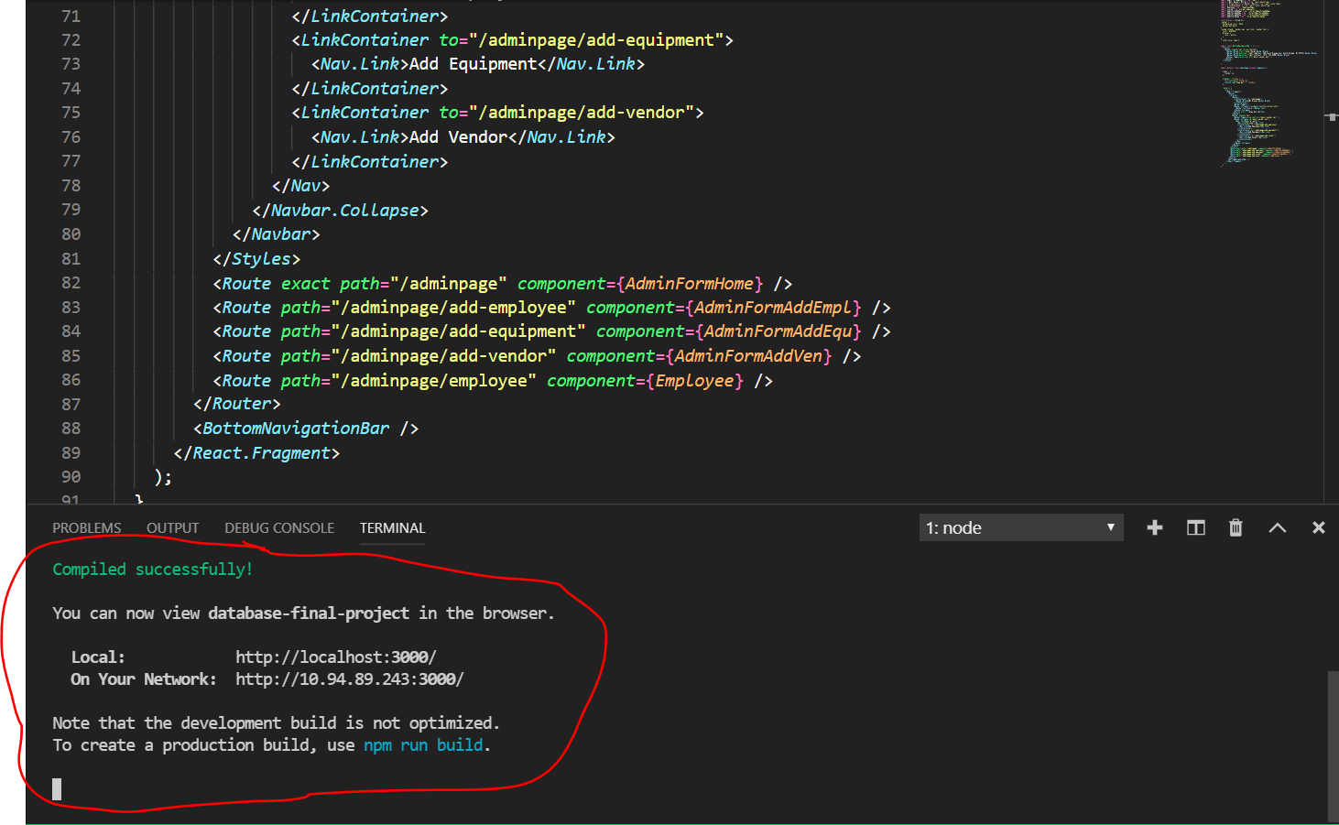

Once the user has pressed Enter, it will open a tab in the user’s web browser to the website. After the website has finished loading up, a user would need to type his or her credentials into the login area on the top right corner of the page.

Once the user hits Submit, based on their credentials, it will either take the user to the Administrator or Employee page.This screenshot is the Administrator home page: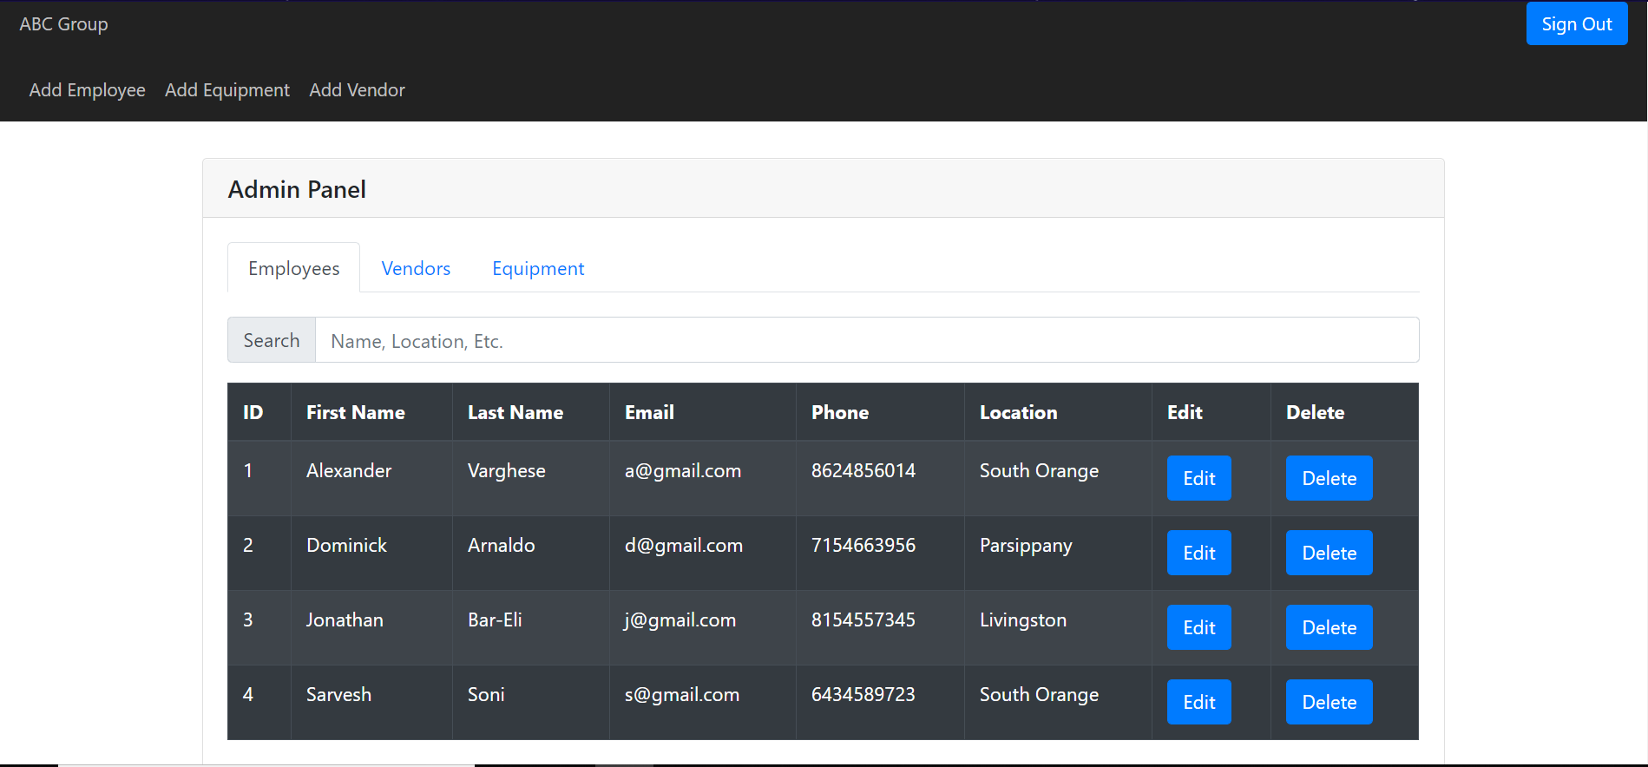

The below screenshot is a screenshot of the Employee home page: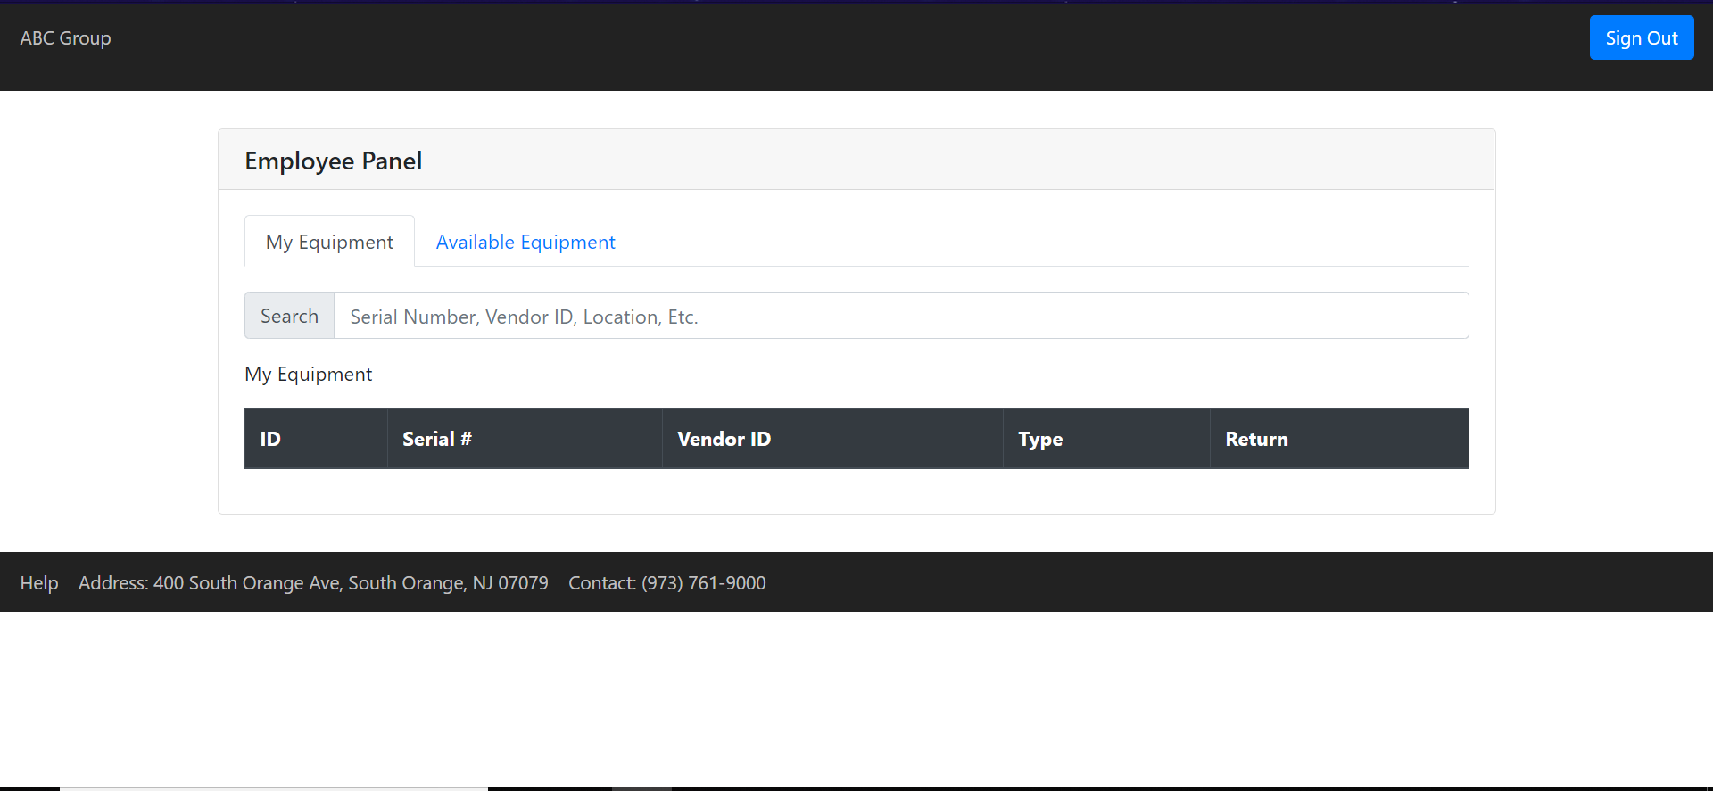

When the administrator logs into the website, the first thing they will see is their Admin Panel. The purpose of this panel is to view, update, and delete employees, vendors, and equipment. In order to edit an employee, vendor, or equipment. The user has to first click Edit and update any of the fields that are provided in the form. 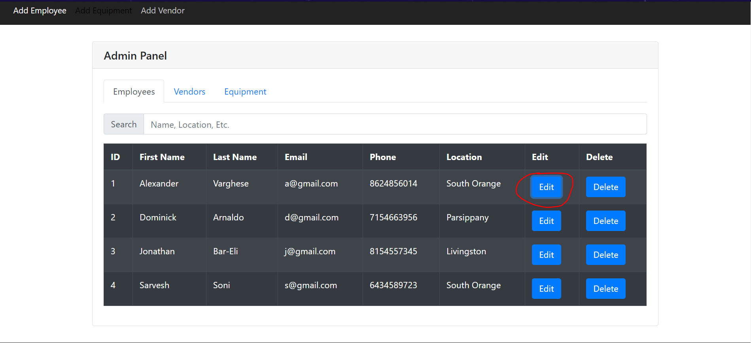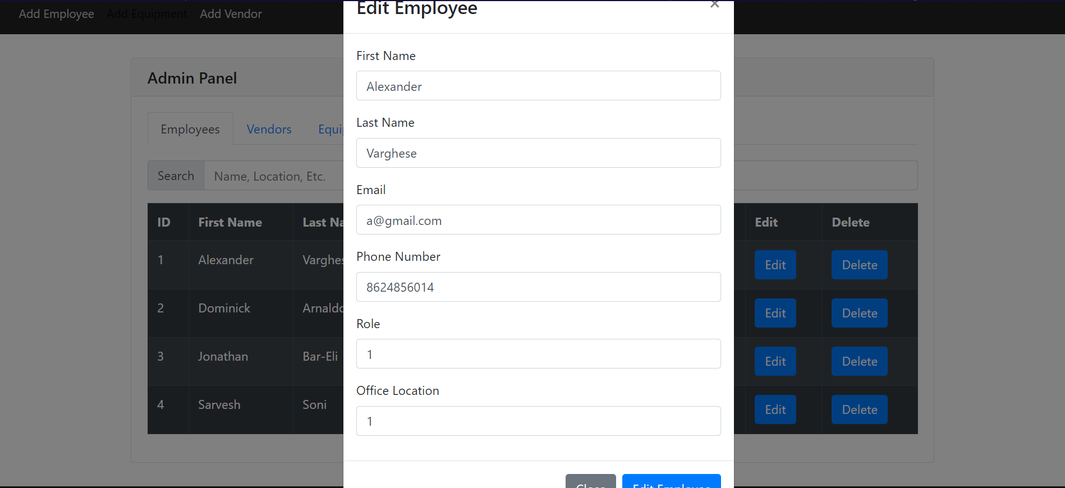 The administrator will also see a couple of tabs called “Add Employee”, “Add Equipment”, and “Add Vendor”. When the administrator clicks on the “Add Employee” page, he/she will be redirected to a form that will allow an him/her to add an employee based on a couple of inputs that need to be filled in.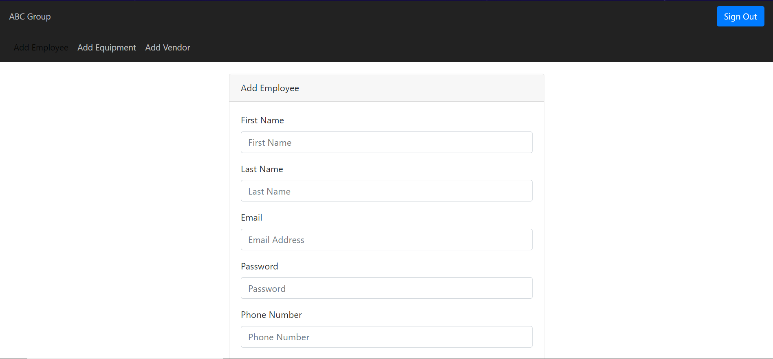

When a user clicks on the “Add Equipment tab”, he/she will be redirected to another form that will allow an Administrator to add an equipment based on a bunch of inputs that will be filled in by the administrator.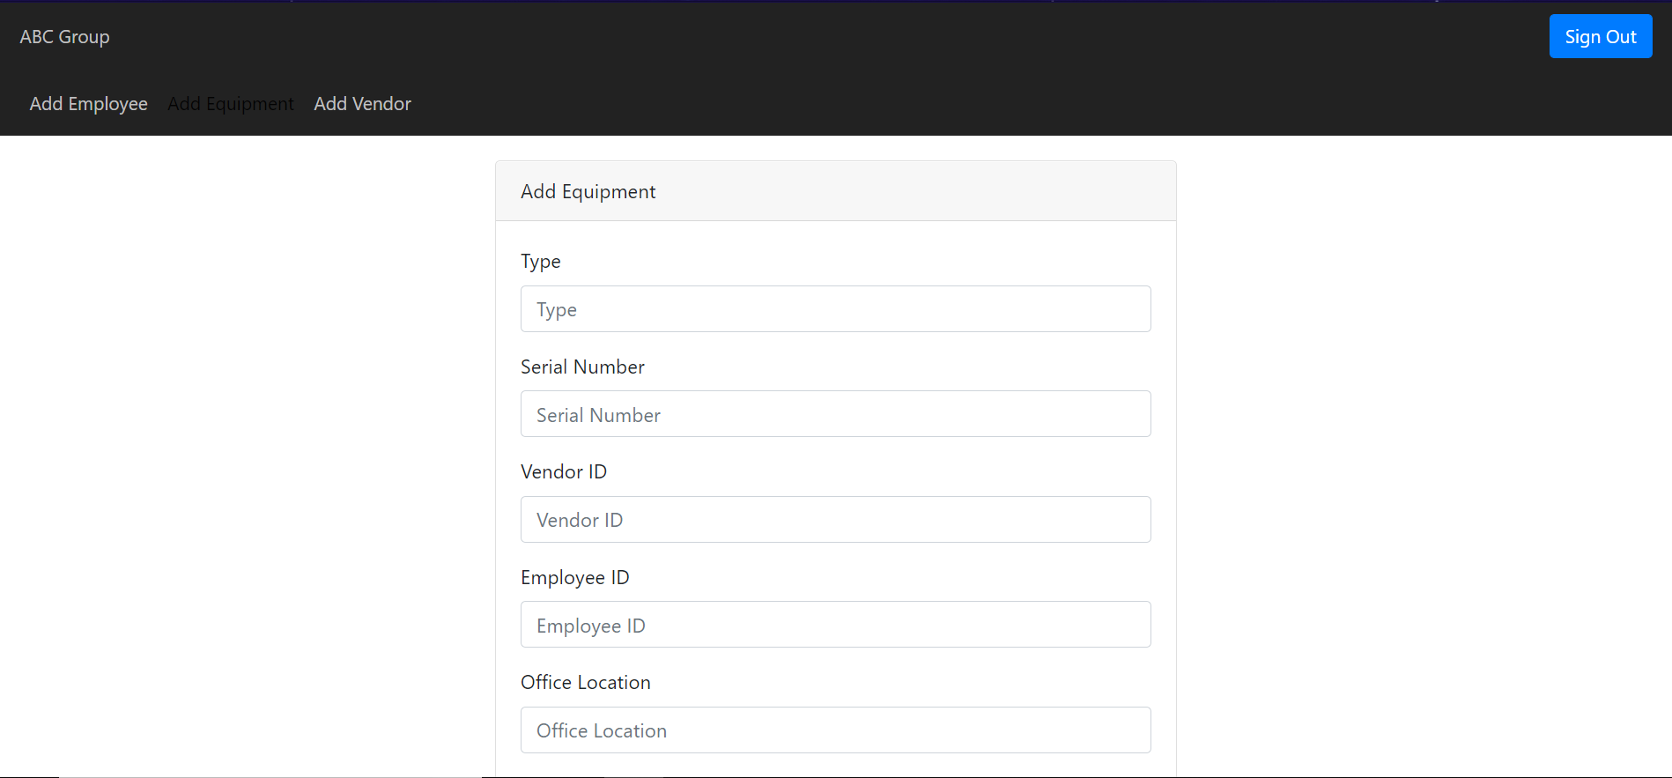

The last tab is where an administrator can add a vendor. In this tab, he/she will be redirected to a form that will add a vendor based on the inputs that the user filled in.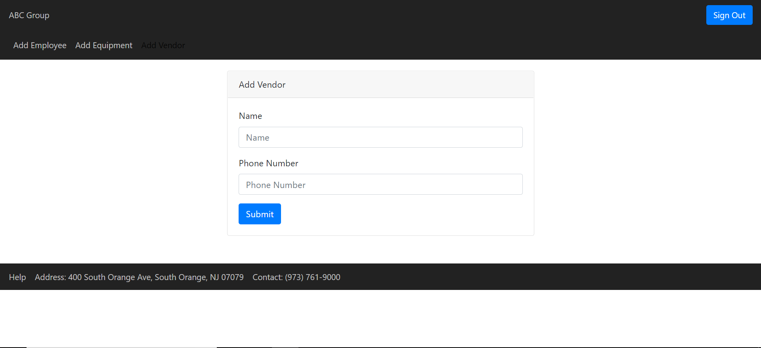

For the Employee home page, employees will only have the ability to view their own equipment and view equipment that is currently available within the organization. 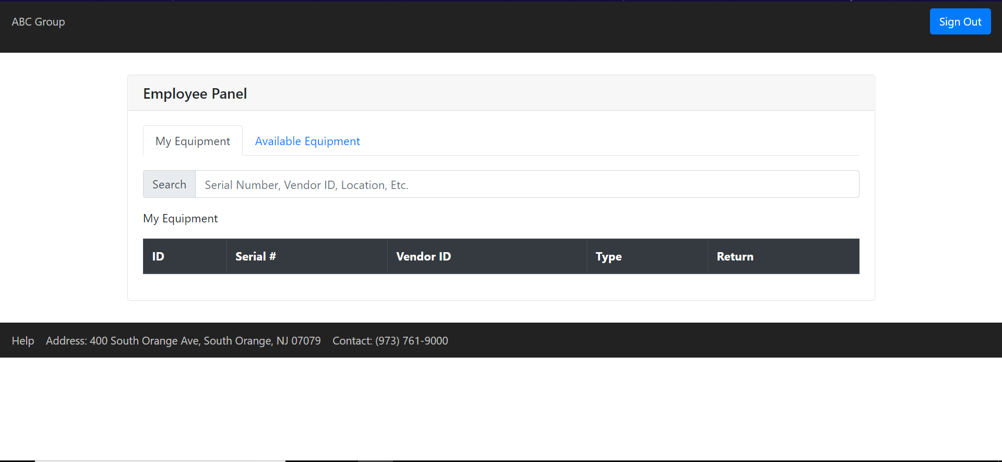

In the “My Equipment” tab under “Employee Panel”, employees only have the ability to return the equipment. In the “Available Equipment” tab, employees have the ability to assign the equipment for themself. An Employee does not have many functions once they have logged into the website but, an administrator has the ability to do all of the functions. If a user wants to go back to the Admin or Employee home page, the user must click on “ABC Group” in the top left corner.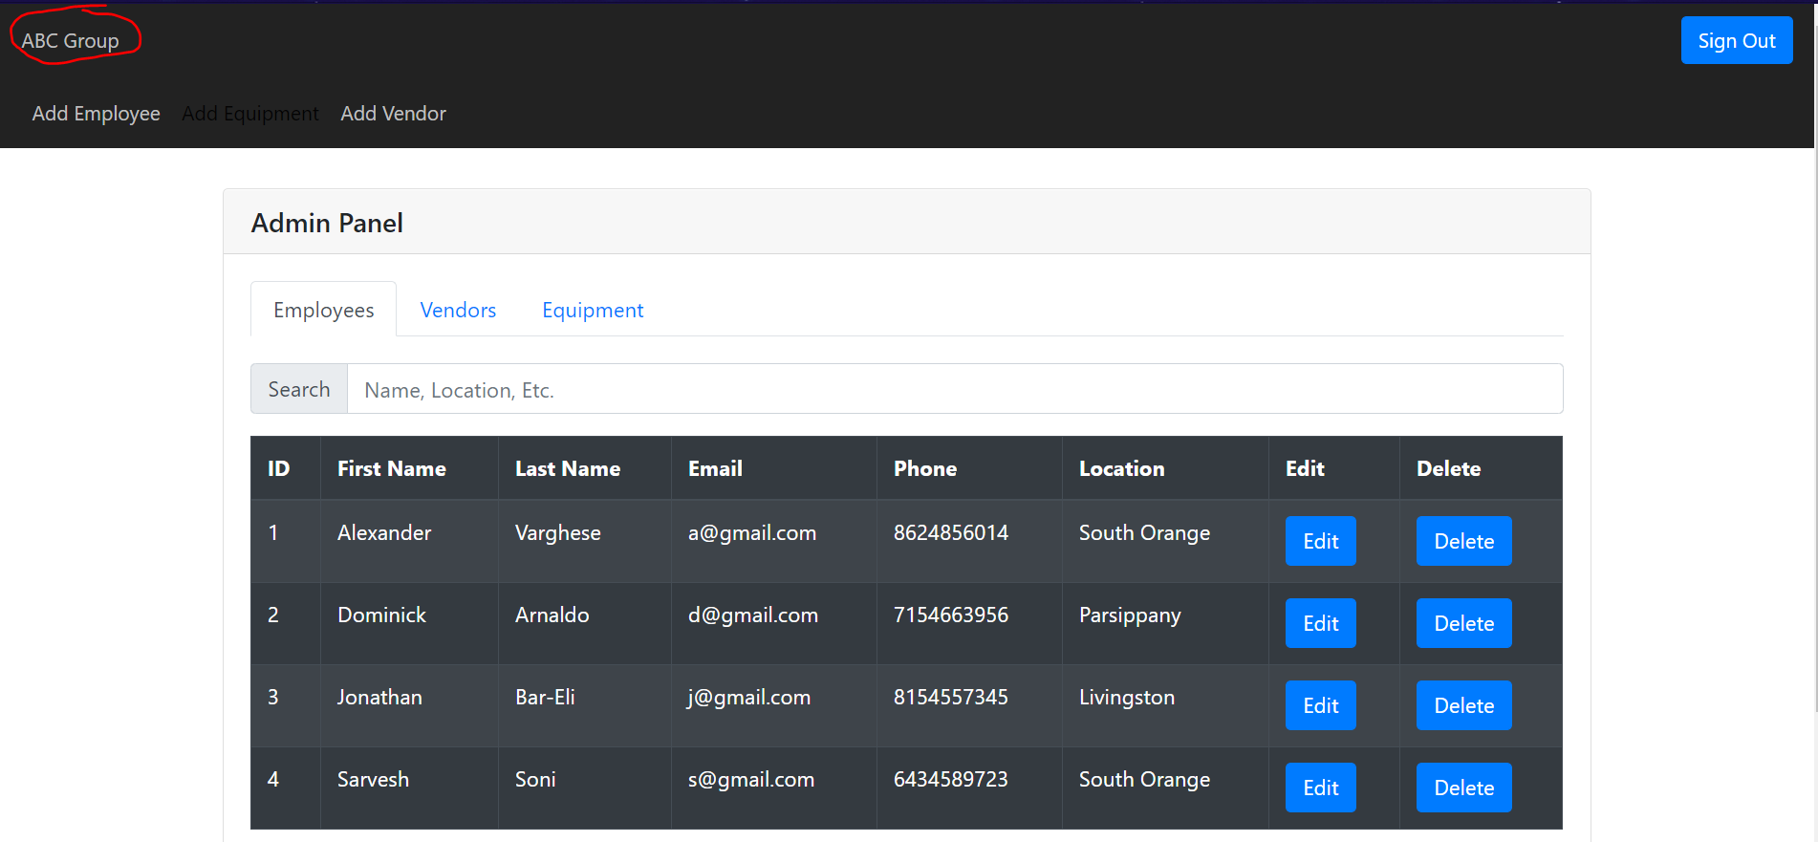

Finally, if a user is done browsing through their account and wants to sign out, they can do so by clicking the “Sign Out” button in the top right hand corner of the page.